- Information and Data
Data: raw factors or observations that are considered to have little or no value until they have been processed and transformed into information.
Information: Data that have been processed so that they are meaningful
Types of information:
Classifications: place data into categories;
Sorting: grouped together or placed into a particular order;
Aggregating: summarising data;
Performing calculations: e.g. calculate employees’ gross pay
Selection: choosing or discarding item of data.
Formal communication: present information in a structured and consistent manner.
Informal communication: less well-structured information, informal means. (casual conversations between member of staff).
The value of information:
Accuracy: is the information correct, can we rely on it?
Timeliness- how current is the information?
Accessibility: can we access the info when we need it?
Engagement: is the information affecting our decision?
Application: is it relevant in the current context?
Rarity: is it previously known or confidential?
MALAGA BOOK SUMMARY
Explain data, information, and information systems.
Data are raw facts and information is raw facts put into context. Information is a valuable asset. The six factors that determine the value of information are: accuracy, timeliness, accessibility, engagement, application and rarity. We can add value to information by pruning, adding context, enhancing style, and choosing the right medium for presentation and distribution. Performing these task is the role of information systems. An information system is a set of interrelated parts that working together to process, store, retrieve, collect and distribute information. The major parts of and information system include computer hardware, software, databases, networks (including the internet) and people. These components interact with each other.
Discuss the use of information system in organizations.
Information system exists to support the various functions and administrative levels within an organization. From administrative perspective, we can divide information system into 7 categories: TPS, OAS, KWS, DSS, MIS, EIS and IOS. There also information system that support functional areas. These systems exist at the various administrative levels within a functional area. Example of functional information systems include finance, accounting ….
Describe the major aspects of working in digital world
In the digital world, an individual’s economic value is increasingly based on how much she knowns. This particularly true for knowledge works, who are people who create new knowledge or modify existing knowledge. They yse brainpower instead of physical power to perform their work. Knowledge workers are professionals who passes a college degree. Data workers are people who enter data into information system. They might not have a college degree, but usually have some training or experience with information system. Information system allow knowledge and data workers to telecommute. Telecommuting allows employees to work from home while providing access to computerized and applications that are available at the office.
Defines ethics and describe the major ethical problem posed by the digital world
Ethics is a set of principles of right conduct. Unlike other professions, information system does not have a generally accepted set of professional ethical standards. In addition, many people who are not part of the information system profession still use information systems. Therefore, individuals need to develop their own set of ethics as they relate to the development and use of information system.
IS in Organizations:
Organization: is an administrative and functional structure applied to people working toward a specific goal
Administrative IS (purposes):
- Transaction Processing System (TPS): support operational-level employees in the organization, who perform the routine day-to-day transactions
- Office Automation System (OAS): support office workers to create, use and manipulate data, but these people do not create new information (word processing and spreadsheet)
- Knowledge Work System (KWS): highly specialised systems used by knowledge workers (professionals who create new information’s as part of their job, e/g doctors.
- Decision Support System (DSS): help managers to make decisions that are not routine. These systems use complex analytical tools, combined with both internal data (coming from inside organizations) and external data (economic indicators).
- Executive Information System (EIS): for strategic planning performed by top executives who required info system tailored to provide the exact information required format.
- InternOrganizational System (IOS): Provide information links between companies and organizational systems. Exist at various levels of the admin. Hierarchy.
Functional IS:
- Finance and Account Systems:
- Marketing and Sales System
- Manufacturing and Operations System
- Human Resources Management System:
Resources that support BIS
- People resources include the users of an information system and those who develop, maintain and operate the system.
- The term hardware resources refers to all types of machines, not just computer hardware.
- In the same way, the term software resources does not only refer to computer programs and the media on which they are stored, but the term can also be used to describe the procedures used by people.
- Resources are also required to enable different systems to transfer data.
- Data resources describe all of the data that an organisation has access to, regardless of its form.
Decision characteristics and Management level
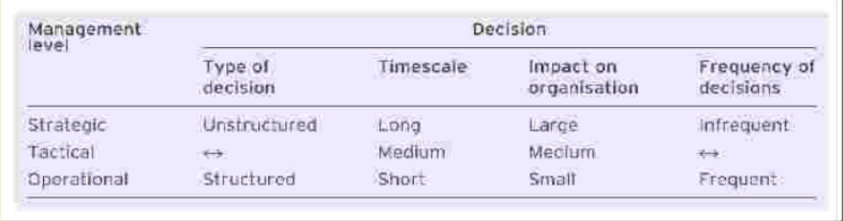
Level of management decision taking
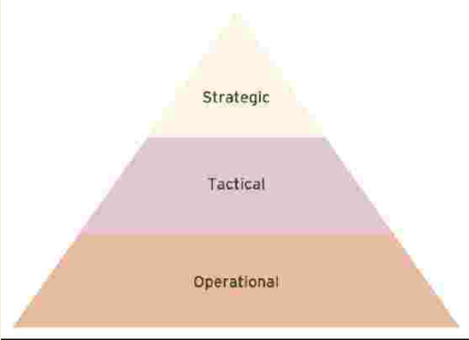
Information characteristics for decision by management level
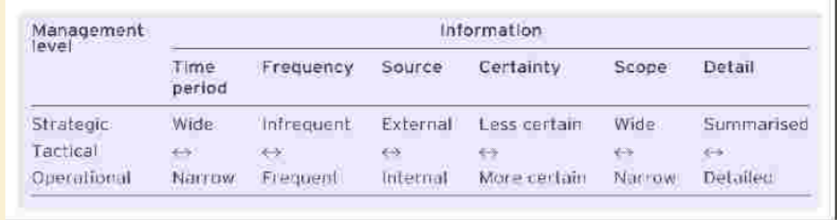

Simon’s model of decision making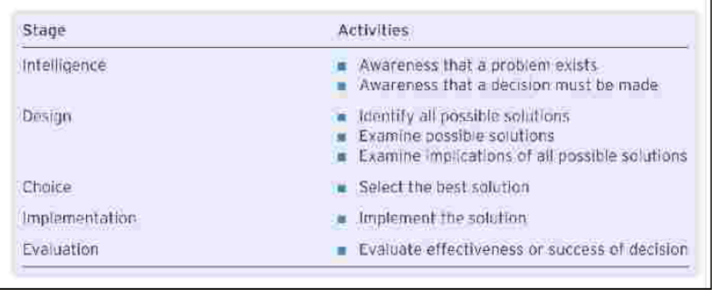
MALAGA BOOK SUMMARY
Describe the decision-Making process based on Simon’s model:
Simon’s decision-making model consists of three phases:
- Intelligence: a person or a group identifies and defines a problem in the intelligence phase.
- Design: the person or group generates potential solutions and methods of evaluating.
- Choice: the person or group applies the evaluation methods to the potential solutions and reaches a decision.
Others have extended Simon’s model to include implementation and analysis. During implementation, the chosen solution is put into action. The analysis phase determines if the implemented solution achieved its goals. This analysis will become part of data used in future intelligence phases.
Describe decision support system
DSS combine data management system with model management systems and a user interface. The data management system stores data and allows users to manipulate it. The model management system contains various models used for decision making. The users interface is an important component of a DSS> It should allow the user to easily manipulate data and models, In addition, the user interface often contain advanced graphical capabilities.
Explain how group DSS work
Groups face their own set of unique problems, such as groups think, production blocking, social loafing, and evaluation apprehension. Groupthink is tendency of the group to succumb to pressure, real or imagined, from higher authority. Production blocking occurs when many people in the group try to speak at once and ideas get lost. Social loafing occurs when some members of the group do not actively participate. When people are afraid their ideas will be ridiculed, evaluation apprehension occurs. GDSS are specifically designed to support decision-making tasks. They usually run in an electronic meeting room and contain tools for brainstorming, categorizing, commenting and voting. GDDS have been extended onto the WWW to allow distributed group decision making.
Describe EIS
Executive information system are computer-based tools that specifically help top-level management make strategic decision. EIS processes both internal and external data. Their main features include the ability to show summary data in graphical form and the ability to drill down into greater levels of detail.
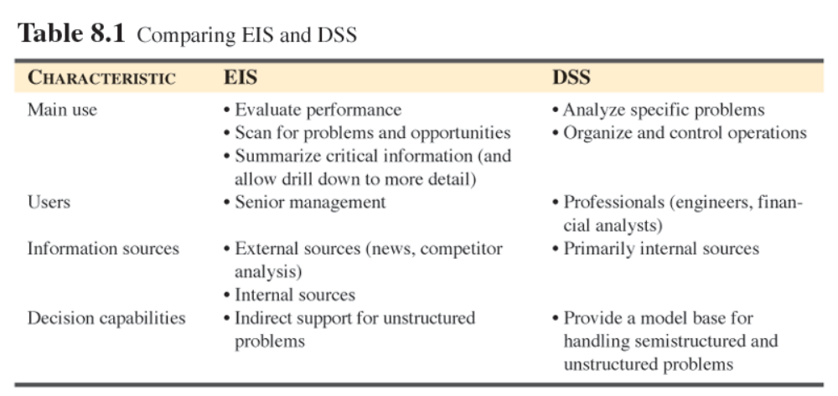

- Acquiring IS
BIS acquisition: The process of evaluating and implementation for a BIS.
Driver’s information system acquisition:
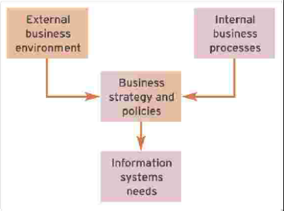

An example of typical evaluation of alternatives for BIS acquisition:
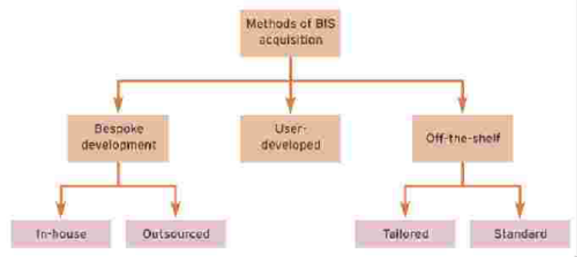

Alternative | Benefit | Disadvantages | Extra
Bespoke  (developed from scratch to suit the business needs) | - Tailored to requirements of business  - Competitive advantage | - Expensive  - Delayed  - May contain bugs
Off-the-Shelf  (direct purchase of a pre-written application used for more than one company) | - Quick purchase  - Low cost  - Stability and featured-rich | - Omit features  - Require changes | - Tailored: has specific programming or extensive configuration tailored to the need of the customer  - Standard: can be configured using pre-written modules
End-User-Developed Software  (written by non-IS professionals | - Tailored to the need of end-users  - Relatively fast | - May not achieve wider business objectives  - May show problems when written by non-IS  - May have difficult maintenance

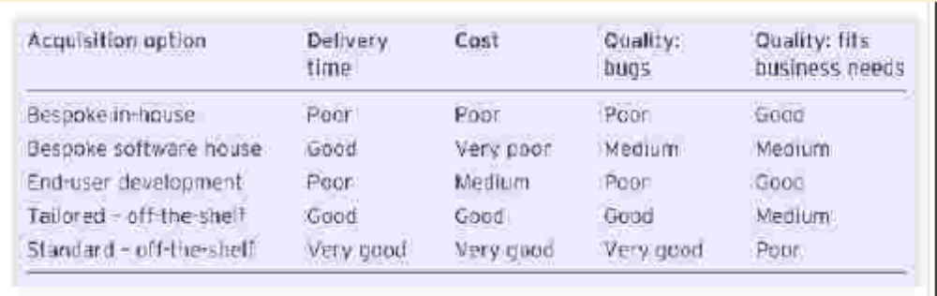

Extra information:
Bespoke: refer to when an information system is developed by an information system professional to match the business requirements of the application. The information system professionals will either work for the business which is termed “in-house” bespoke development or for a third party sucha as a software house which is termed ‘outsourced’ software development. Bespoke development has benefit of producing software tailored to the precise requirements of the business. In terms of time bespoke development, epecially when using formal structured development methodologies, is notorious four time overruns, with delays of months or years not uncommon and quality. Finally, in terms of quality bespoke software is not usually free from bugs; software bugs can range from the trivial to the catastrophic, the latter often attribuate to poor analysis of requirements.
Off-the-shelf purchase: of packaged software is an acquisition method tahat involves direct purchase of a pre-written application used by more than one company. This type of software is pre-written and is avaiable for a whole variety of hardware plataforms from PCs to mainframes. Off-the-Shelf software is written to offer a broad funcionality that will suit for a number of business. It als may offer too many features for any particular business, which may othen feel that is paying for things it will not use. At the same time, it may require business to process information in a particular way that is at odds with the way they normally do business. Alternatively, a certain off-the-shelf software package may not offer sufficient features . The major benefit however, of off-the-shelf software packages is their low cost when compared with acquiring bespoke software with the same level of funcionality. In addition, because packaged software has been developed for a commercial market, it is less likely to suffer from bug that afflict bespoke software. In a tailored off-the-shelf purchase, pre-written software is purchased from a supplier, but it possible to configure it to be specific to the company. In a component off-the-shelf purchase, different modules may be purchased from differen suppliers and built together.
End-User-Developed software: is a software written by non-IS professionals i.e business users.
Enterprise resource planning or instutuinal applications are those that affect general corporate activities, cut across more than one department or funcitonal area, or system that involve organisational data held in corporate databases. Examples include accounting system, sales order processing system and material requirements planning. End-user-dapplications are more limited in scope. Applications may be depatmental pr personal in nature and are usually output- or report-oriented rather than input-driven. The main benefit of end-user-developed software is that it is normally used by those who develop it, and so the requirements are not subject to mistranslation or the provision of over-sophisticated solutions. The negative side to this is that in some cases innapropriate software development tools might be used as complicated spreadsheets instead of the constructions of a database. A further significant concern with it is that software may be riddled with bugs as a consequance of corner cutting such as poor or non-existent design, little or no testing, or no documentation.
Factors affecting software aquisition
There a number of factors that will influence the choice of acquisition method. Three critical ones are time, cost and quality considerations. If an organizations has pressing problem that requires a new information system quickly probable that a packages or tailored packaged will be sought. Similarly, an organisation that needs a ‘quality system solution’ may well consider the packaged software route, especially if its requirements are straightforward. The different acquisition option have different strengths when consider in terms of the three critical criteria. Quality of the delivere product is considered from two respects: the number of bugs or errors found and the suitability of the software in meeting the requirements of the business user. Note that good quality in termos of the number of bugs that typically occur for packaged software may coincide with poor quality in terms of business fit. The benefit of packaged software occurs because the cost of developing and debugging the software is shared between more than one company. This results in lower costs and fewer bugs than bespoke development for a single company. The use of packaged software by more the one company is also greatest weakness, since its features must suit the typical company. As a consequence, it may not meet the needs of an individual company. Others factors affecting software acquisition include the following:
- Organization size: A small or medium business will inevitably have relatively resources for purchasing of IS and information technology. This suggest that there will be a tendency for such organizations to favour the purchased off-the-shelf packages or possibly or possibly end-user applications.
- In-house IS: Where little in –house expertise exists, either in form of IS professionals or experienced end-users, there will be a need to use third parties in the acquisition of the new business IS. There may include software vendors for off-the-shelf software packages, the use of consultants and/or software houses. Precisely what form of third party is used will depend on other factors.
- Complexity of the required information system. Where a business information system requirement is particularly complex, or for an unusual application not available as a packaged solution, it is possible that one may view bespoke software (either developed in-house or by a third party) as the only viable solution. However, complexity does not necessarily equate to ‘uniqueness’. For example, one could regard a materials requirements planning system or a complete accounting system as complex, but many packages exist for
- Uniqueness of the business or business area to be supported. The higher the degree of uniqueness that exists in the area to be supported, the less likely it is that a suitable off-the-shelf package can be found. This is clearly an indicator, therefore, for bespoke development of some kind. As before, we must not confuse uniqueness with complexity. It may well be feasible for a non-IS/IT specialist to develop a solution using tools available to end-user developers. Of course, if the required system is complex and also carries a high degree of uniqueness, then bespoke development by IS/IT professionals is probably the best acquisition method.
- IS/IT expertise among end-users. A certain degree of IS/IT literacy and expertise is necessary if end-users are to be able to develop information systems. In addition, such literacy is desirable when selecting suitable off-the-shelf packaged software, as it can help the business focus more clearly on its precise requirements from both a functional and a technological perspective. If an organisation has little end-user IS/IT expertise of its own, but has its own IS/IT department, it will be very much dependent on solutions provided by IS/IT professionals with or without third-party support.
- Linkages with existing applications software. Where new business software needs to integrate very tightly with existing information systems, there is a higher probability that at least some bespoke development work will need to be done to integrate the two systems. Also, a high degree of integration may imply that the new information system has to be developed in a bespoke fashion in order to achieve the desired level of integration. Having said that, many software vendors supply packages for different business areas which integrate very well with each other.

Developing Information System
The systems development life cycle (SDLC) is the classical approach used to develop information systems (Kroenke, 2007). The SDLC approach recognises that systems are developed in a series of steps or phases and that each phase needs to be completed before the next one commences. Recognition is also given to the fact that the programming activity (part of the build phase) should only commence once user requirements have been determined and the system design produced.
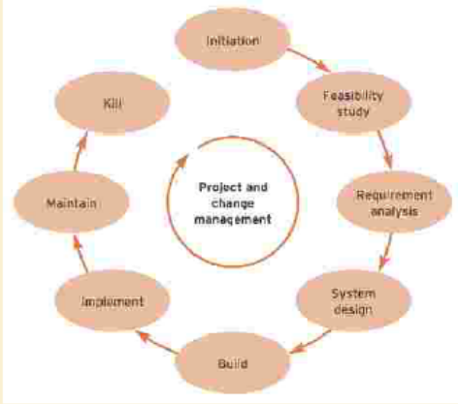
- Initiation: The systems development life cycle (SDLC) is the classical approach used to develop information systems (Kroenke, 2007). The SDLC approach recognises that systems are developed in a series of steps or phases and that each phase needs to be completed before the next one commences. Recognition is also given to the fact that the programming activity (part of the build phase) should only commence once user requirements have been determined and the system design produced. We will now summarise the basic steps that most systems development projects follow.
- Feasibility: assessment is the activity that occurs at the start of the project to ensure that the project is a viable business proposition. The feasibility report analyses the need for and impact of the system and considers different alternatives for acquiring software. The feasibility assessment can be considered to be part of the initiation phase. It will establish whether a computer-based information system fits certain feasibility criteria
- Systems analysis: is the capture of the business requirements of a system from talking to or observing end-users and using other information sources such as existing system documentation. Once a proposed information system is agreed to be feasible, it is necessary to carry out the detailed work of assessing the precise requirements that the intended users have for the new system. Note that the systems analysis step is sometimes referred to as the ‘requirements determination’ step or the ‘systems study’ step. There are three main tasks within this phase. First, it is necessary to gain an understanding of how the current information system (computerised or paper-based) works. Second, a diagrammatic model of the current system workings is produced to ensure that IT professionals and system users are in agreement. Finally, a set of requirements for the new information system is produced.
- Design: The systems design phase defines how the system will work in key areas of user interface, program modules, security and database transactions. The input to this stage is a breakdown of the requirements that the proposed information system is to deliver. The task of the systems design stage is to convert those requirements into a number of design alternatives from which the best will be selected.
- System built: System build is the creation of software by programmers. It involves writing the software code (programming), building release versions of the software, constructing and populating the database and testing by programmers and end-users. Writing of documentation and training may also occur at this stage. The term ‘build’ is one that we shall be using in addition to the more usual and ambiguous term ‘implementation’ which is found in many texts and methodologies. This step embraces three substeps: physical database construction, programming and testing. Physical database construction involves the conversion of the database design from the previous step into the required tables and indexes of a relational database. The programming substep involves the construction of computer code that will handle data capture, storage, processing and output. In addition, it will be necessary to program various other operational attributes of the required system (e.g. those that stem from control design). Alongside and subsequent to the programming substep, various forms of testing will take place. The output from the build stage will be an information system that has been tested and is available for final data conversion or take-on and live operation. If during the build phase it appears from testing that the system does not meet the original requirements as determined during the analysis step, then it will be necessary to revisit the design step to see whether any errors were made in interpreting the systems requirements. If the design brief was correctly interpreted but the system still contains errors in the delivery of the perceived requirements, it will be necessary to revisit the analysis to determine the systems requirements more precisely.
- Implementation and changeover: System implementation covers practical issues such as making sure the hardware and network infrastructure for a new system are in place; testing of the system; and also human issues of how best to educate and train staff who will be using or affected by the new system. Implementation also involves the transition or changeover from the old system to the new. This step in the waterfall model deals with preparing for and making the change from old to new information systems. As one might expect, the systems implementation step is fraught with difficulties. Here, it will be discovered whether all the previous steps have combined to deliver an information system that does what the users actually want and that also works properly. Data will be converted from old information systems or directly entered into the new database. Finally, the new system will become operational straight away, or in phases, or after a period of parallel running. If errors are encountered at the live running stage it may be possible for the system to continue in operation while the errors are corrected. Alternatively, it may be necessary to suspend the operation of the new system while the most significant errors are fixed. Such error correction may require any of the previous steps to be revisited, depending on the nature and severity of the error(s). It will be clear from this short discussion that the later in the systems development process errors are discovered, the higher is the cost of putting them right. The worst-case scenario is probably for a system to have reached the live running stage only for it to be discovered that the required system was never really feasible in the first place.
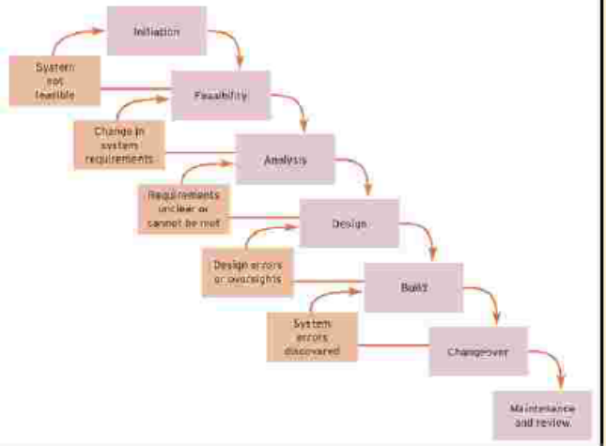

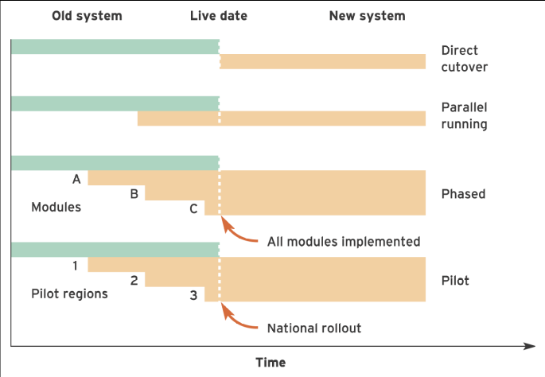

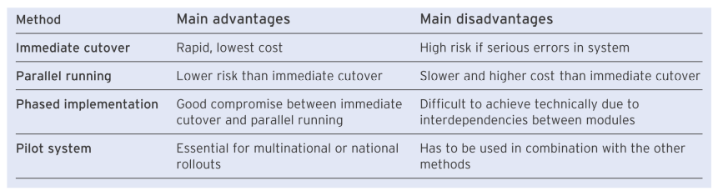

- Review and maintenance: Once an information system is operating under live running conditions, it will be inevitable that changes will be required over time. The maintenance phase involves two different types of maintenance. The first, known as ‘unproductive maintenance’, stems from errors or oversights in the original systems development which, while not preventing the system operating to an acceptable level, are still necessary to correct for it to conform with the original specification. The second form of maintenance involves the addition of new features and facilities that extend the scope and functionality of the information system. In the early days, these may take the form of ‘nice-to-haves’ or ‘bells and whistles’ which were not deemed to be essential to the system at changeover time. Over the longer term, the system will be adapted and modified to meet changing business requirements. An activity known as the post-implementation review should also be undertaken. This should take place about six months after the system changeover and should review what was planned for the information system against what actually happened. Lessons learned from this exercise will be extremely valuable when the next system is developed.

Rapid Applicants development - RAD
Not only is there pressure from end-user management for faster systems development, IS/IT departments themselves increasingly recognise the need to make more effective use of limited human resources within their departments while at the same time quickly delivering systems that confer business benefits. All this is in a climate of rapid business change and, therefore, rapidly changing information needs. Rapid applications development (RAD) is a possible solution to these problems and pressures. This uses prototyping to involve users and increase development speed. Rapid applications development (RAD) is a method of developing information systems which uses prototyping to achieve user involvement and faster development compared to traditional methodologies such as SSADM. Prototyping produces a preliminary version of part or a framework of all of an information system which can be reviewed by end-users. Prototyping is an iterative process where users suggest modifications before further prototypes and the final information system are built.
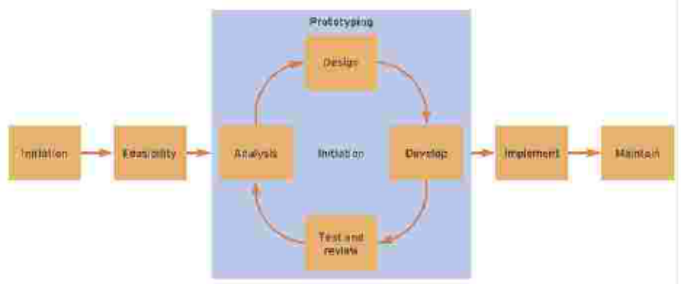

Spiral Model
The spiral model is aniterative systems developmentmodel developed by Boehm (1988) which incorporates risk assessment. The spiral model was developed in recognition of the fact that systems development projects tend to repeat the stages of analysis, design and code as part of the prototyping process. Each spiral consists of four main activities which are:

- Planning. Setting project objectives, defining alternatives.

- Risk analysis. Analysis of alternatives and the identification and solution of risks.

- Engineering. Equivalent to the build phase of the SDLC with coding and testing.

- Customer evaluation. Testing of the product by customers.

The model is closely related to RAD, since it implies iterative development with a review possible after each iteration or spiral, which corresponds to the production of one prototype or incremental version. Before the first spiral starts the requirements plan is produced, so it can be seen that the spiral model does not detail the initiation and analysis phase of the SDLC, focusing on design and build. Although the spiral model has not been applied widely in industry, proponents of this model argue that it includes the best features of both the classic SDLC and the prototyping approach. It also adds validation of requirements and design, together with risk analysis, which is often overlooked in RAD projects.

